SATISFACTION QUESTIONNAIRE

Thank you for attending our workshop GENDER EQUALITY AWARENESS RAISING WORKSHOP FOR SMEs / CLUSTERS.
We are kindly asking you to fill in the following satisfaction questionnaire, necessary for the evaluation of the workshop and the future improvement and implementation of the Penelope project.
Pls. answer the following questions by choosing the variant you feel best expresses your opinion:

- How would you rate the overall organisation of the workshop?
Very Poor | Poor | Neutral | Good | Excellent

- Was the workshop duration appropriate for covering the topics effectively?
Too short | Just right | Too long

- How clear and well-structured was the presentation of the information?
Very unclear | Somewhat unclear | Neutral | Clear | Very clear

- Was the language used appropriate and easy to understand?
Yes | No | Partially

- Did the speakers/facilitators explain the topics in an engaging and understandable way?
Strongly disagree | Disagree | Neutral | Agree | Strongly agree

- Were the visual aids (slides, videos, etc.) helpful in supporting the presentation?
Yes | No | Partially

- To what extent did the workshop encourage participant interaction and engagement?
Not at all | A little | Neutral | Quite a lot | A great deal

- The information presented encouraged me to study more on the subject matter
Strongly disagree | Disagree | Neutral | Agree | Strongly agree

- I am interested in exploring the results of the Penelope project
Strongly disagree | Disagree | Neutral | Agree | Strongly agree

- What aspects of the workshop organisation could be improved? (Open-ended response)

- Do you have any additional comments or suggestions for future workshops? (Open-ended response)

Thank you for your participation!

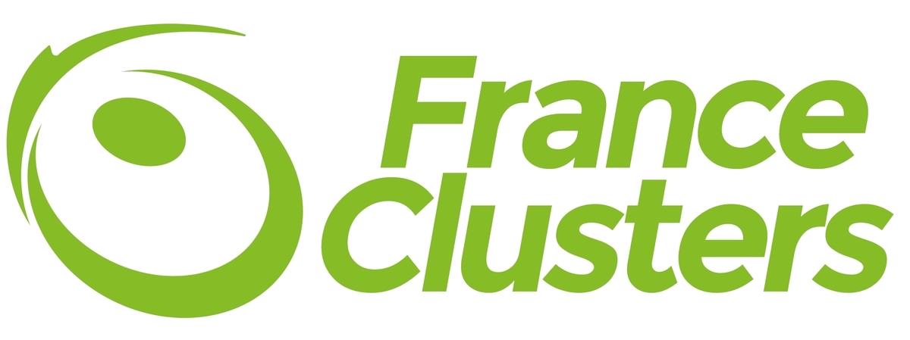





PENELOPE has been funded by the European Union.
(2022-1-FR01-KA220-VET-000088824).
Views and opinions expressed are however those of the author(s) only and do not necessarily reflect those of the European Union or the European Education and Culture Executive Agency (EACEA). Neither the European Union nor EACEA can be held responsible for them.

